**Topic: Project Management**

**Case: Project Management Analysis in the Internet Forecasting Industry**

**Questions**

**Analyse the project by answering the following questions:**

Q 1: Construct the project network (activity-on-node diagram). List all the paths of the project network.

Q 2: Using the **“most likely”** time estimates, what is the completion time for this project? Identify the critical path(s) of the project. Identify the critical and non-critical tasks. What is the cost of the project?

Q 3: Using the **“most optimistic”** time estimates, what is the completion time for this project? Identify the critical path(s) of the project. Identify the critical and non-critical tasks. What is the cost of the project?

Q 4: Using the **“most pessimistic”** time estimates, what is the completion time for this project? Identify the critical path(s) of the project. Identify the critical and non-critical tasks. What is the cost of the project?

Q 5: If **we account for the uncertainty in the duration of the tasks**, what is the estimated completion time for this project? (Use the “expected time” estimates for your calculations). Identify the critical path(s) of the project. Identify the critical and non-critical tasks. What is the cost of the project? Compute the range of the project durations by accounting for the uncertainty in the duration of the tasks.

1. Use Triangular distribution to find the expected values of activity time.

**Expected Activity Duration (EAD) = (P + M + 0) / 3**

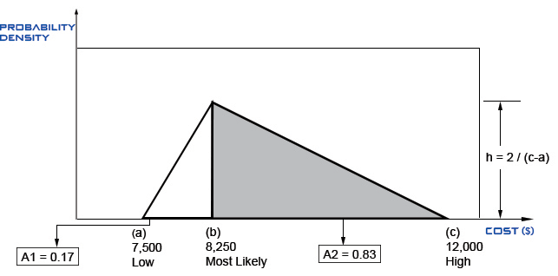

1. Use Beta distribution to find the expected values of activity time.

**Expected Activity Duration (EAD) = (P + 4M + 0) / 6**

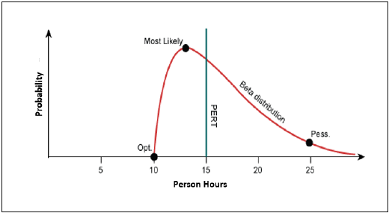

Q 6: Compute the variance of the activities as well as the critical path and comment of the risks involved.

* **Activity Variance =** [**(P - O)/6] ^2**
* **Activity Standard Deviation = (P - O)/6**
* **Variance of critical path = sum of variances of critical activities on that path.**

Q 7: What is the probability that the project can be completed in 40 weeks? OR What is the level of confidence that the project can be completed by the mean duration of the 40 weeks?

* Use the excel function NORMDIST (X, mean, standard deviation, cumulative frequency) to compute the probability.

Q 8: What is the probability that the project can be completed in 35 weeks? OR What is the level of confidence that the project can be completed by the mean duration of the 35 weeks?

* Use the excel function NORMDIST (X, mean, standard deviation, cumulative frequency) to compute the probability.

Q 9: What is the impact of the mean duration of project completion time on the probability of the completion of the project? Illustrate through a plot.

Q 10: The project manager would like to reduce the duration of the project to 35 weeks. Clearly indicate the activities to crash, the resulting expected project time and associated costs at each step.

Q 11: Based on the information provided, what is the maximum crashing that can be achieved. Clearly indicate the activities to crash, the resulting expected project time and associated costs at each step.

Q 12: Plot the crashing cost curve (project duration vs. total project cost). What insights do this curve provide?

Q 13: The project manager wanted to investigate the impact on the crashing solution if the expected time for task B (market assessment) was increased from seven to nine weeks. Clearly indicate the activities to crash, the resulting expected project time and associated costs at each step.

Q 14: The project manager wanted to see the impact on the crashing solution if the expected time for task D (development) was decreased to seven weeks. Clearly indicate the activities to crash, the resulting expected project time and associated costs at each step.

Q 15: Analyze the impact on the crashing solution if the expected time for task B (market assessment) was increased from seven to nine weeks whereas the expected time for task D (development) was decreased to seven weeks simultaneously. Clearly indicate the activities to crash, the resulting expected project time and associated costs at each step.

**Practice Questions**

Q 16: If we ignore the uncertainty in the duration of the tasks, i.e., use the “most likely time” estimates for your calculations, clearly indicate the activities to crash, the resulting expected project time, and associated costs at each step.